Rodrigo Becerril Ferreyra
Dr. Gevik Sardarbegian
CECS 440 Section 02
26 October 2021
Lab 4
This lab tasked us with creating a 16-bit Arithmetic Logic Unit (ALU) from 16 different 1-bit ALUs that can add, subtract, OR, or AND two bits. Both ALU modules were verified with the code I provided below. The full adder module was verified last lab. I did not verify the multiplexer, AND gate, or OR gate modules because they are very simple. To verify these, I simply looked at the block diagram that was created using the Elaborated Design feature of Vivado. Note that I performed modifications on the multiplexer module, because the block diagram looked very off, and I could not guarantee that it works as intended. Additionally, your version uses RTL_LATCHES. These latches should be avoided at all costs, unless the designer explicitly creates one. Latches mean that there is likely a case statement that does not consider all options. Here are the block diagram for your mux module and mine:
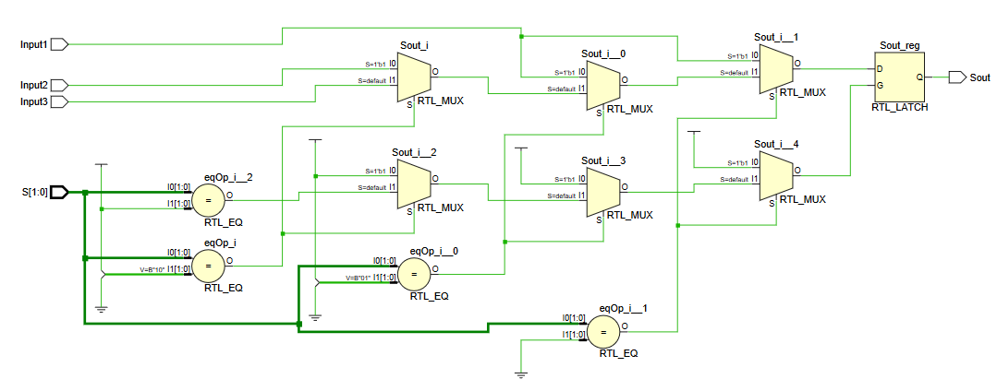
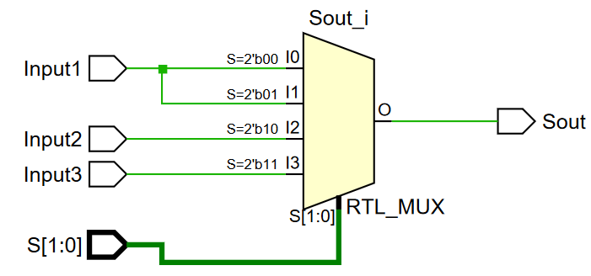
Please note that high-quality vector .pdf files of these images are available in the Lab submission. The following source files are also available there.
full_adder.vhd
--------------------------------------------------------------------------------
-- Company: California State University, Long Beach
-- Engineer: Rodrigo Becerril Ferreyra
--
-- Create Date: 10/12/2021 11:54:07 PM
-- Design Name: full_adder
-- Module Name: full_adder
-- Project Name: CECS 440 Lab 3
-- Description: A simple 1-bit wide full adder.
--
-- Dependencies:
--
-- Revision: 1
--------------------------------------------------------------------------------
library IEEE;
use IEEE.STD_LOGIC_1164.ALL;
use IEEE.NUMERIC_STD.ALL;
entity full_adder is
port
(
a: in std_logic;
b: in std_logic;
cin: in std_logic;
sum: out std_logic;
cout: out std_logic
);
end full_adder;
architecture Behavioral of full_adder is
begin
-- two simple assign statements for a one-bit adder
sum <= a xor b xor cin;
cout <= (a and b) or (b and cin) or (cin and a);
end Behavioral;

and_gate.vhd
Library ieee;
Use ieee.std_logic_1164.all;
Use ieee.std_logic_unsigned.all;
Entity and_gate is
port(
In1 : in std_logic;
In2 : in std_logic;
Sout : out std_logic
);
End;
Architecture behavior of and_gate is
Begin
-- In1 In2 Sout
-- 0 0 0
-- 0 1 0
-- 1 0 0
-- 1 1 1
-- and gate logic
Sout <= In1 and In2;
End;

or_gate.vhd
----------------------------------------------------------------------------------
-- Company: California State University, Long Beach
-- Engineer: Rodrigo Becerril Ferreyra
--
-- Create Date: 10/25/2021 11:46:06 AM
-- Module Name: or_gate - Behavioral
-- Project Name: Lab 4
----------------------------------------------------------------------------------
library IEEE;
use IEEE.STD_LOGIC_1164.ALL;
--use IEEE.NUMERIC_STD.ALL;
entity or_gate is
port
(
In1 : in std_logic;
In2 : in std_logic;
Sout: out std_logic
);
end or_gate;
architecture Behavioral of or_gate is
begin
Sout <= In1 or In2;
end Behavioral;

MUX31.vhd
----------------------------------------------------------------------------------
-- Company: California State University, Long Beach
-- Engineer: Rodrigo Becerril Ferreyra
-- Module Name: MUX31 - Behavioral
-- Project Name: Lab 4
-- Description: I improved the mux block (is now an actual mux).
-- The last version had an RTL_LATCH in it, which I hear is something to avoid
----------------------------------------------------------------------------------
library ieee;
use ieee.std_logic_1164.all;
use ieee.std_logic_unsigned.all;
entity MUX31 is
-- define ports
port
(
Input1: in std_logic;
Input2: in std_logic;
Input3: in std_logic;
S: in std_logic_vector(1 downto 0);
Sout: out std_logic
);
end MUX31;
architecture Behavioral of MUX31 is
begin
process (S, Input1, Input2, Input3)
begin
case S is
when "00" => Sout <= Input1;
when "01" => Sout <= Input1;
when "10" => Sout <= Input2;
when "11" => Sout <= Input3;
when others => Sout <= 'Z';
end case;
end process;
end Behavioral;

ALU1bit.vhd
----------------------------------------------------------------------------------
-- Company: California State University, Long Beach
-- Engineer: Rodrigo Becerril Ferreyra
--
-- Create Date: 10/25/2021 11:31:08 AM
-- Module Name: ALU1bit - Behavioral
-- Project Name: Lab 4
----------------------------------------------------------------------------------
library ieee;
use ieee.std_logic_1164.all;
use ieee.std_logic_unsigned.all;
use IEEE.NUMERIC_STD.ALL;
-- assign top-level ports
entity ALU1bit is
port(
A : in std_logic;
B : in std_logic;
Cin : in std_logic;
S : in std_logic_vector(1 downto 0);
Sout : out std_logic;
Cout : out std_logic
);
end ALU1bit;
Architecture behavior of ALU1bit is
-- intstantiate full_adder module
component full_adder
port
(
a : in std_logic;
b : in std_logic;
cin : in std_logic;
sum : out std_logic;
cout : out std_logic
);
end component;
-- intstantiate MUX31 module
component MUX31
port
(
Input1 : in std_logic;
Input2 : in std_logic;
Input3 : in std_logic;
S : in std_logic_vector(1 downto 0);
Sout : out std_logic
);
end component;
-- intstantiate and_gate module
component and_gate
port
(
In1 : in std_logic;
In2 : in std_logic;
Sout : out std_logic
);
end component;
-- intstantiate or_gate module
component or_gate
port
(
In1 : in std_logic;
In2 : in std_logic;
Sout : out std_logic
);
end component;
-- signal definitions
signal Sout_full_adder: std_logic;
signal Sout_and_gate : std_logic;
signal Sout_or_gate : std_logic;
signal Xor_out : std_logic;
signal Cin_muxed : std_logic;
begin
-- assign statements
-- flips B if S(0) is 1
Xor_out <= B xor S(0);
-- If S(0) is set (subtract mode), then a 1 should always go into the
-- Cin port on the full adder (two's compliment is flip all bits
-- then add 1). If S(0) is cleared, then simply pass Cin into
-- the Cin port in full_adder.
--with S(0) select Cin_muxed <= '1' when '1', Cin when '0', 'Z' when others;
fulladderblock: full_adder
port map
(
a => A,
b => Xor_out,
cin => Cin,
sum => Sout_full_adder,
cout => Cout
);
andgateblock: and_gate
port map
(
In1 => A,
In2 => B,
Sout => Sout_and_gate
);
orgateblock: or_gate
port map
(
In1 => A,
In2 => B,
Sout => Sout_or_gate
);
muxblock: MUX31
port map
(
Input1 => Sout_full_adder,
Input2 => Sout_and_gate,
Input3 => Sout_or_gate,
S => S,
Sout => Sout
);
end;
ALU16bit.vhd
----------------------------------------------------------------------------------
-- Company: California State University, Long Beach
-- Engineer: Rodrigo Becerril Ferreyra
--
-- Create Date: 10/25/2021 01:23:54 PM
-- Module Name: ALU16bit - Behavioral
-- Project Name: Lab 4
----------------------------------------------------------------------------------
library IEEE;
use IEEE.STD_LOGIC_1164.ALL;
--use IEEE.NUMERIC_STD.ALL;
-- define top-level ports for ALU16bit
entity ALU16bit is
port
(
A: in std_logic_vector(15 downto 0);
B: in std_logic_vector(15 downto 0);
S: in std_logic_vector(1 downto 0);
Cout: out std_logic;
Sout: out std_logic_vector(15 downto 0)
);
end ALU16bit;
architecture Behavioral of ALU16bit is
-- ALU1bit declaration
component ALU1bit
port(
A : in std_logic;
B : in std_logic;
Cin : in std_logic;
S : in std_logic_vector(1 downto 0);
Sout : out std_logic;
Cout : out std_logic
);
end component;
-- cin-cout inbetween wires
signal inbetween: std_logic_vector(14 downto 0);
begin
Sum0: ALU1bit
port map
(
A => A(0),
B => B(0),
Cin => S(0),
S => S,
Cout => inbetween(0),
Sout => Sout(0)
);
Sum1: ALU1bit
port map
(
A => A(1),
B => B(1),
Cin => inbetween(0),
S => S,
Cout => inbetween(1),
Sout => Sout(1)
);
Sum2: ALU1bit
port map
(
A => A(2),
B => B(2),
Cin => inbetween(1),
S => S,
Cout => inbetween(2),
Sout => Sout(2)
);
Sum3: ALU1bit
port map
(
A => A(3),
B => B(3),
Cin => inbetween(2),
S => S,
Cout => inbetween(3),
Sout => Sout(3)
);
Sum4: ALU1bit
port map
(
A => A(4),
B => B(4),
Cin => inbetween(3),
S => S,
Cout => inbetween(4),
Sout => Sout(4)
);
Sum5: ALU1bit
port map
(
A => A(5),
B => B(5),
Cin => inbetween(4),
S => S,
Cout => inbetween(5),
Sout => Sout(5)
);
Sum6: ALU1bit
port map
(
A => A(6),
B => B(6),
Cin => inbetween(5),
S => S,
Cout => inbetween(6),
Sout => Sout(6)
);
Sum7: ALU1bit
port map
(
A => A(7),
B => B(7),
Cin => inbetween(6),
S => S,
Cout => inbetween(7),
Sout => Sout(7)
);
Sum8: ALU1bit
port map
(
A => A(8),
B => B(8),
Cin => inbetween(7),
S => S,
Cout => inbetween(8),
Sout => Sout(8)
);
Sum9: ALU1bit
port map
(
A => A(9),
B => B(9),
Cin => inbetween(8),
S => S,
Cout => inbetween(9),
Sout => Sout(9)
);
Sum10: ALU1bit
port map
(
A => A(10),
B => B(10),
Cin => inbetween(9),
S => S,
Cout => inbetween(10),
Sout => Sout(10)
);
Sum11: ALU1bit
port map
(
A => A(11),
B => B(11),
Cin => inbetween(10),
S => S,
Cout => inbetween(11),
Sout => Sout(11)
);
Sum12: ALU1bit
port map
(
A => A(12),
B => B(12),
Cin => inbetween(11),
S => S,
Cout => inbetween(12),
Sout => Sout(12)
);
Sum13: ALU1bit
port map
(
A => A(13),
B => B(13),
Cin => inbetween(12),
S => S,
Cout => inbetween(13),
Sout => Sout(13)
);
Sum14: ALU1bit
port map
(
A => A(14),
B => B(14),
Cin => inbetween(13),
S => S,
Cout => inbetween(14),
Sout => Sout(14)
);
Sum15: ALU1bit
port map
(
A => A(15),
B => B(15),
Cin => inbetween(14),
S => S,
Cout => Cout,
Sout => Sout(15)
);
end Behavioral;
ALU1bit_tb.vhd
----------------------------------------------------------------------------------
-- Company: California State University, Long Beach
-- Engineer: Rodrigo Becerril Ferreyra
--
-- Create Date: 10/25/2021 12:37:32 PM
-- Module Name: ALU1bit_tb - Behavioral
-- Project Name: Lab 4
----------------------------------------------------------------------------------
library IEEE;
use IEEE.STD_LOGIC_1164.ALL;
--use IEEE.NUMERIC_STD.ALL;
entity ALU1bit_tb is
end ALU1bit_tb;
architecture Behavioral of ALU1bit_tb is
-- declare unit under test
component ALU1bit
port
(
A : in std_logic;
B : in std_logic;
Cin : in std_logic;
S : in std_logic_vector(1 downto 0);
Sout : out std_logic;
Cout : out std_logic
);
end component;
-- declare signals
signal A_tb: std_logic := '0';
signal B_tb: std_logic := '0';
signal Cin_tb: std_logic := '0';
signal S_tb: std_logic_vector(1 downto 0) := "00";
signal Sout_tb: std_logic;
signal Cout_tb: std_logic;
constant tick: time := 100 ns;
begin
-- instantiate ALU1bit as uut
uut: ALU1bit
port map
(
A => A_tb,
B => B_tb,
Cin => Cin_tb,
S => S_tb,
Sout => Sout_tb,
Cout => Cout_tb
);
-- process to change A
process
begin
wait for tick;
A_tb <= not A_tb;
end process;
-- process to change B
process
begin
wait for (tick*2);
B_tb <= not B_tb;
end process;
-- process to change Cin
process
begin
wait for (tick*4);
Cin_tb <= not Cin_tb;
end process;
-- process to change S(0)
process
begin
wait for (tick*8);
S_tb(0) <= not S_tb(0);
end process;
-- process to change S(1)
process
begin
wait for (tick*16);
S_tb(1) <= not S_tb(1);
end process;
end Behavioral;

ALU16bit_tb.vhd
----------------------------------------------------------------------------------
-- Company: California State University, Long Beach
-- Engineer: Rodrigo Becerril Ferreyra
--
-- Create Date: 10/25/2021 04:45:35 PM
-- Module Name: ALU16bit_tb - Behavioral
-- Project Name: Lab 4
----------------------------------------------------------------------------------
library IEEE;
use IEEE.STD_LOGIC_1164.ALL;
--use IEEE.NUMERIC_STD.ALL;
entity ALU16bit_tb is
end ALU16bit_tb;
architecture Behavioral of ALU16bit_tb is
-- define unit to test
component ALU16bit
port
(
A: in std_logic_vector(15 downto 0);
B: in std_logic_vector(15 downto 0);
S: in std_logic_vector(1 downto 0);
Cout: out std_logic;
Sout: out std_logic_vector(15 downto 0)
);
end component;
-- define signals
signal A_tb: std_logic_vector(15 downto 0) := "0000000000000000";
signal B_tb: std_logic_vector(15 downto 0) := "0000000000000000";
signal S_tb: std_logic_vector(1 downto 0) := "00";
signal Cout_tb: std_logic;
signal Sout_tb: std_logic_vector(15 downto 0);
constant tick: time := 50 ns;
begin
-- instantiate ALU16bit and tie inputs/outputs
uut: ALU16bit
port map
(
A => A_tb,
B => B_tb,
S => S_tb,
Cout => Cout_tb,
Sout => Sout_tb
);
-- main process
process
begin
S_tb <= "00";
A_tb <= x"0096"; -- 150
B_tb <= x"0104"; -- 260
wait for tick;
S_tb <= "00";
A_tb <= x"FFE7"; -- -25
B_tb <= x"0041"; -- 65
wait for tick;
S_tb <= "00";
A_tb <= x"0002"; -- 2
B_tb <= x"0002"; -- 2
wait for tick;
S_tb <= "01";
A_tb <= x"0226"; -- 550
B_tb <= x"0140"; -- 320
wait for tick;
S_tb <= "01";
A_tb <= x"0019"; -- 25
B_tb <= x"003C"; -- 60
wait for tick;
S_tb <= "01";
A_tb <= x"FFFE"; -- -2
B_tb <= x"0010"; -- 16
wait for tick;
S_tb <= "10";
A_tb <= x"0040"; -- 64
B_tb <= x"0100"; -- 256
wait for tick;
S_tb <= "10";
A_tb <= x"07D0"; -- 2000
B_tb <= x"0003"; -- 3
wait for tick;
S_tb <= "10";
A_tb <= x"14DE"; -- 5342
B_tb <= x"03DA"; -- 986
wait for tick;
S_tb <= "11";
A_tb <= x"000C"; -- 12
B_tb <= x"0007"; -- 7
wait for tick;
S_tb <= "11";
A_tb <= x"0000"; -- 0
B_tb <= x"0929"; -- 2345
wait for tick;
S_tb <= "11";
A_tb <= x"FFFF"; -- -1
B_tb <= x"0005"; -- 5
wait for tick;
-- exits the simulation
report "simulation finished successfully" severity FAILURE;
end process;
end Behavioral;

Results:
S1 | S0 | A | B | Sout | Cout
0 | 0 | 150 | 260 | 410 | 0
0 | 0 | -25 | 65 | 40 | 1
0 | 0 | 2 | 2 | 4 | 0
0 | 1 | 550 | 320 | 230 | 1
0 | 1 | 25 | 60 | -35 | 0
0 | 1 | -2 | 16 | -18 | 1
1 | 0 | 64 | 256 | 0 | 0
1 | 0 | 2000 | 3 | 0 | 0
1 | 0 | 5342 | 968 | 218 | 0
1 | 1 | 12 | 7 | 15 | 1
1 | 1 | 0 | 2345 | 2345 | 0
1 | 1 | -1 | 5 | -1 | 1

